LAB EXPERIMENT RECORD

Set 10: Survey Responses Analysis

Field | Details
Department | AI&DS
Course Code / Course Name | DSA0602/ Data Handling and Visualization
Experiment | Data Visualization using R
Name | M V Raghavan
Register Number | 192424373
Date | 06 October 2026
Day | Tuesday

Aim

To analyse survey responses using a grouped bar chart, a stacked bar chart and a data table in R, and to build an interactive dashboard that combines them.
Dataset: Survey Responses

Survey ID | Question 1 | Question 2 | Question 3
1 | A | B | C
2 | B | A | D
3 | C | A | B

PROGRAM 1: Grouped Bar Chart for Question 1

Create a grouped bar chart to visualize the distribution of answers for Question 1. Label the chart elements.
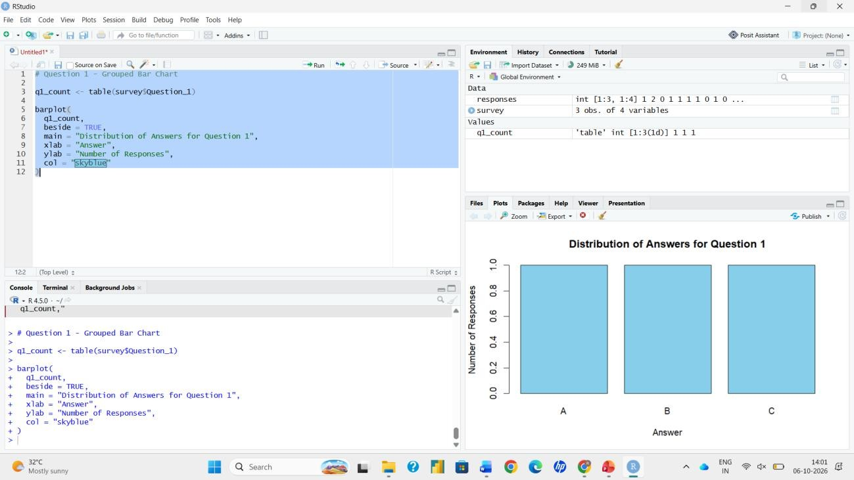
library(ggplot2)

# Dataset
survey <- data.frame( SurveyID = c(1, 2, 3), Question1 = c("A", "B", "C"),
Question2 = c("B", "A", "A"),
Question3 = c("C", "D", "B")
)

# Grouped Bar Chart (Question 1)
ggplot(survey, aes(x = Question1, fill = factor(SurveyID))) + geom_bar(position = position_dodge2(preserve = "single")) + labs(title = "Distribution of Responses for Question 1",
x = "Response Option",
y = "Number of Respondents", fill = "Survey ID")

Output 1: Question 1 Grouped Bar Chart

PROGRAM 2: Stacked Bar Chart for All Questions

Generate a stacked bar chart to represent the overall distribution of responses for all three questions.
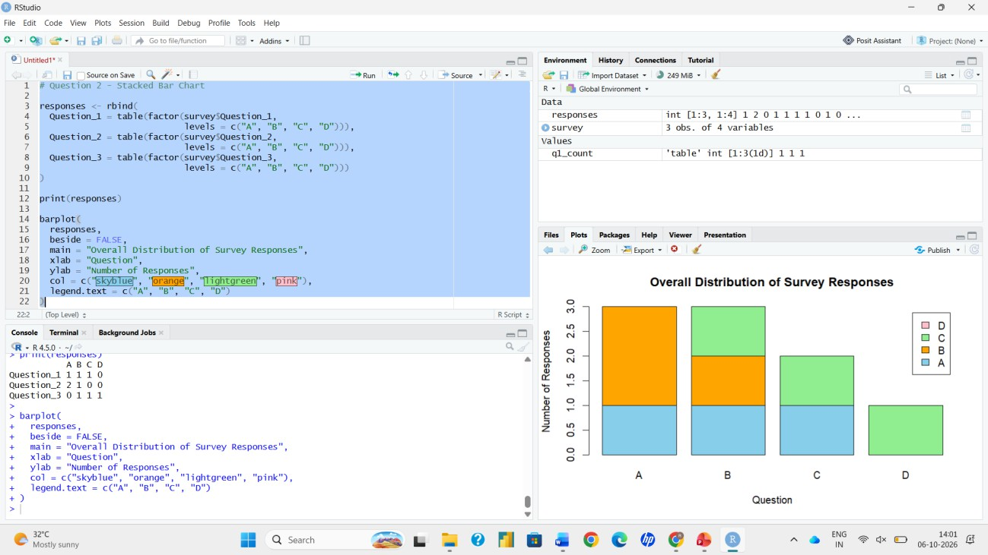
library(ggplot2) library(tidyr)

# Convert data to long format long <- pivot_longer(survey,
cols = starts_with("Question"), names_to = "Question", values_to = "Response")

# Stacked Bar Chart
ggplot(long, aes(x = Question, fill = Response)) + geom_bar(position = "stack") +
labs(title = "Overall Distribution of Responses (All Questions)", x = "Question",
y = "Number of Responses", fill = "Response")

Output 2: Stacked Bar Chart of All Questions

PROGRAM 3: Survey Response Table

Build a table to show the survey response data for each survey. Label the table elements.
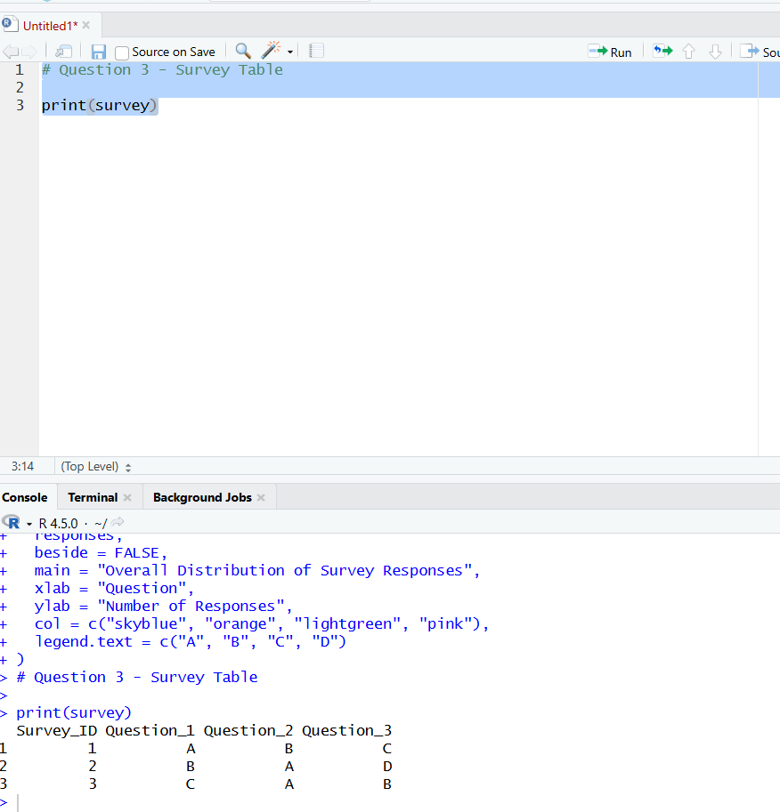
# Display the survey data as a labelled table
colnames(survey) <- c("Survey ID", "Question 1", "Question 2", "Question 3") print(survey)
View(survey)

Output 3: Survey Response Table

PROGRAM 4: Interactive Shiny Dashboard

Build an interactive dashboard combining the grouped bar chart, stacked bar chart and the table using the Shiny package.
library(shiny) library(ggplot2) library(tidyr)

survey <- data.frame( SurveyID = c(1, 2, 3), Question1 = c("A", "B", "C"),
Question2 = c("B", "A", "A"),
Question3 = c("C", "D", "B")
)

long <- pivot_longer(survey, cols = starts_with("Question"), names_to = "Question", values_to = "Response")

ui <- fluidPage(
titlePanel("Survey Responses Dashboard"), sidebarLayout(
sidebarPanel(
selectInput("q", "Select Question (Grouped Bar Chart):", choices = c("Question1", "Question2", "Question3"))
),
mainPanel( plotOutput("grouped"), plotOutput("stacked"), tableOutput("tbl")
)
)
)

server <- function(input, output) { output$grouped <- renderPlot({
ggplot(survey, aes(x = .data[[input$q]], fill = factor(SurveyID))) + geom_bar(position = position_dodge2(preserve = "single")) + labs(title = paste("Distribution of Responses for", input$q),
x = "Response Option", y = "Number of Respondents", fill = "Survey ID")
})
output$stacked <- renderPlot({
ggplot(long, aes(x = Question, fill = Response)) + geom_bar(position = "stack") +
labs(title = "Overall Distribution of Responses (All Questions)",
x = "Question", y = "Number of Responses", fill = "Response")
})
output$tbl <- renderTable({
colnames(survey) <- c("Survey ID", "Question 1", "Question 2", "Question 3") survey
})
}

shinyApp(ui = ui, server = server)

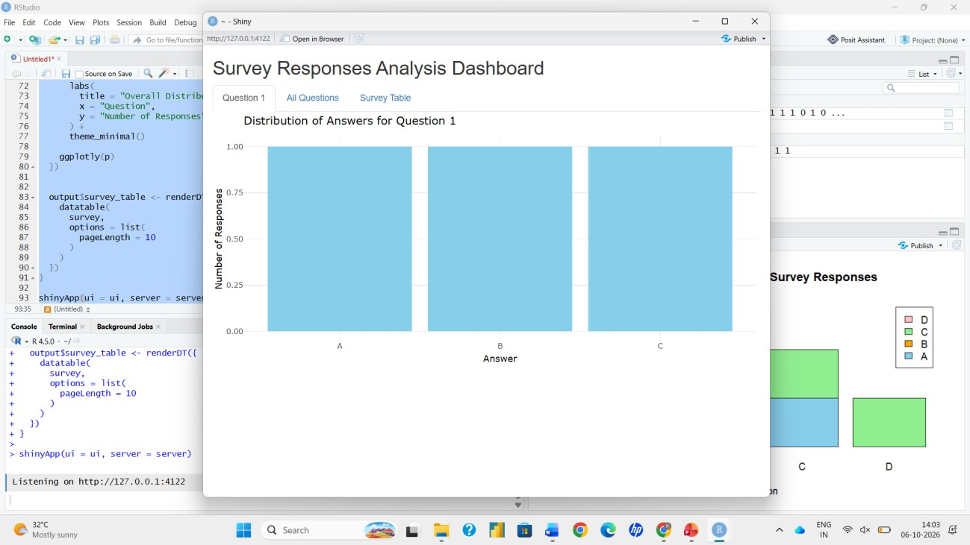
Output 4: Interactive Dashboard

